**Final Project Report**

**Effectiveness of Customer Support Interactions on Twitter**

**Team Members:**

Abhaya Shukla: U42968713

Dhruv Toshniwal: U28189255

Rohan Sawant: U47249888

**Research Question:**

The central question of our research is, "How effective are customer support interactions on Twitter, and what patterns of communication contribute to successful resolutions?" This inquiry is novel in its comprehensive exploration of various dimensions of digital customer support on a major social media platform. Unlike traditional studies that primarily focus on generic customer support metrics, this project delves deep into the multifaceted nature of interactions on Twitter, a platform where public visibility adds a unique dimension to customer service.

**Novelty and Significance:**

The novelty of this research lies in its holistic approach, encompassing not just basic metrics like response time or volume but also advanced analyses like sentiment analysis, topic modeling, etc. This comprehensive view is significant in today's digital age, where customer service on social media platforms plays a crucial role in brand perception and customer satisfaction. By examining a wide range of factors - from sentiments to conversation structures and the effectiveness of support - the research provides a more intricate understanding of how customer support unfolds in the digital space and its impact.

In our study, we concentrated on pivotal aspects like sentiment analysis, response time, topic modeling, support effectiveness, user engagement, link analysis, and language patterns. This focus was chosen due to its potential to unveil significant insights into the dynamics of customer support on Twitter. Our motivation lies in understanding how social media, particularly Twitter's direct and public interactions, shapes customer-brand relationships. The goal is to merge traditional customer service metrics with the intricate realities of social media, providing valuable perspectives for enhancing digital customer support's quality and efficacy.

**Dataset Description:**

The chosen dataset is from Kaggle, titled "Customer Support on Twitter." It contains over three million tweets and replies from some of the most prominent brands on Twitter. The dataset includes variables such as tweet ID, author ID, creation time, text of the tweet, and related response IDs. This dataset is suitable because it offers a comprehensive view of customer-brand interactions, allowing for a detailed analysis of support effectiveness, user engagement patterns, and communication styles.

Dataset Link: <https://www.kaggle.com/datasets/thoughtvector/customer-support-on-twitter>

**Description of the chosen variables:**

The primary variables of interest include:

* **Tweet Content**: Crucial for sentiment analysis, it allows us to detect the emotions and attitudes expressed by users, be it positive, negative, or neutral. The text also offers a window into language patterns and communication styles, helping us to unravel linguistic choices and nuances, and categorize discussions into distinct themes and topics.
* **Creation Time**: This element aids in tracking response times and identifying temporal trends in user-brand interactions. Such data is instrumental in gauging response efficiency and understanding how interaction patterns evolve over time.
* **Author ID:** By identifying frequent users, we can explore engagement patterns and preferences, offering insights crucial for tailoring customer experiences and fostering enduring relationships.
* **Inbound Status:** Distinguishing between customer queries and brand responses, this variable enables us to analyze the effectiveness and dynamics of customer service engagements.
* **Response ID:** Key to linking individual tweets with their responses, enabling us to analyze entire conversation threads for context and effectiveness of support. This feature aids in scrutinizing the responsiveness of support accounts by identifying which tweets were acknowledged and which weren't, thereby assessing the efficiency of customer support.

**Operationalization Concepts:**

1. **Effectiveness of Support:**

* Frequency of Follow-up Interactions: We used response tweet IDs to track the number of follow-up interactions for each support account. This allowed us to quantify the extent to which these accounts maintained ongoing dialogues with users, beyond the first response. A higher frequency of such interactions was interpreted as indicative of more effective support, implying sustained engagement.
* Sentiment Change Post-Response: Utilizing TextBlob’s sentiment analysis, we assessed the sentiment polarity of tweets before and after the response from support accounts. This analysis helped us measure whether the user sentiment shifted somewhat positively following support responses, which would suggest effective issue resolution and improved user satisfaction.

1. **Popularity of a Support Account:**

* Number of Interactions (Tweets and Replies): We analyzed the volume of interactions each support account had, including both tweets directed at the account and replies from it. This was done by counting the number of tweets and responses associated with each support account's ID. A higher interaction count was taken to reflect greater popularity, suggesting the account's significant role in user engagement.

**Methods:**

Utilizing a quantitative approach, the study aims to comprehensively analyze the vast and structured Twitter customer support dataset. Through sentiment analysis with tools like TextBlob, the research will discern the emotional undertones of tweets, classifying them into positive, negative, or neutral sentiments. This will offer insights into customer satisfaction and the efficacy of support responses, especially when comparing initial and follow-up tweets. Additionally, by tokenizing tweets and conducting frequency and bigram/trigram analyses using NLTK, common themes and recurring issues will be pinpointed. Additionally, the study employs Latent Dirichlet Allocation (LDA) to uncover deeper thematic structures within the data, identifying key topics prevalent in customer interactions. This multifaceted approach aims to provide a nuanced understanding of customer support dynamics on Twitter, spotlighting user satisfaction, prevalent trends, interaction patterns, and recurrent discussion topics, ultimately offering a roadmap for enhancing digital customer support.

**Computational Methods from Class:**

1. **Latent Dirichlet Allocation (LDA):**

* One of the key computational methods used was LDA, a technique introduced in class.
* LDA was employed to perform topic modeling on the Twitter dataset, helping to identify the underlying themes in customer support interactions.
* The LDA model was trained on the processed tweets, and coherence scores were calculated to assess the model's effectiveness.
* This method provided valuable insights into the predominant topics in customer queries and responses, which was instrumental in understanding the nature and variety of issues addressed in customer support on Twitter.

**Other Methods Used:**

1. **Sentiment Analysis using TextBlob:**

* To gauge the sentiment of customer interactions, we used TextBlob, a natural language processing library.
* Sentiment analysis helped determine the emotional tone of the tweets, categorizing them as positive, negative, or neutral. This was crucial in understanding the impact of support interactions on customer sentiment.

1. **Response Time Analysis:**

* We calculated the average response time for each support account, which helped in evaluating the timeliness of customer support responses.
* This analysis was vital to assess the efficiency of support accounts in addressing customer queries.

1. **User Engagement Patterns:**

* The frequency of interactions from individual users was analyzed to identify frequent users and their engagement patterns.
* This approach was key to understanding user behavior and preferences in the context of customer support.

1. **Link Analysis:**

* We examined the URLs included in tweets to understand how external resources were utilized in support interactions.
* This analysis revealed the common domains and types of content shared in customer support tweets.

1. **Volume and Trends Analysis:**

* The dataset was analyzed over time to observe trends in the volume of customer queries, providing insights into the temporal dynamics of customer support interactions.

**Findings:**

1. **Latent Dirichlet Allocation (LDA) (Visualization 10):**

* **Topic Diversity:** LDA revealed a broad spectrum of topics in Twitter's customer support interactions, spanning from technical queries to general customer concerns, highlighting the platform's diverse use in customer support.
* **Moderate Coherence Score:** The coherence score of 0.3888 suggests moderate clarity in the topics identified, indicating both the effectiveness of the model and the potential for further refinement to enhance topic distinctiveness.
* **Role of URLs:** The frequent inclusion of URLs within tweets points to a trend of integrating external resources into customer support, enhancing the depth and efficiency of digital support.
* **Topic Relationships:** The Intertopic Distance Map effectively displayed the relationships between various topics, offering insights into overlapping and unique customer concerns.
* **Term Relevance Adjustments:** Utilizing the λ metric allowed for a detailed exploration of topic-specific terms, aiding in distinguishing the most defining words of each topic.
* **Interactive Data Exploration:** The tool's interactivity facilitated a deeper understanding of topic compositions and the nature of discussions, enriching the overall analysis.
* **Complex Nature of Queries:** The study underscores the complexity and variety in customer support inquiries on Twitter, emphasizing the need for adaptive and well-informed support strategies.
* **Utility of Advanced NLP:** The effective use of LDA highlights the potential of advanced NLP techniques in extracting comprehensive insights from large-scale social media data, offering valuable guidance for enhancing digital customer support.

1. **Sentiment Analysis using TextBlob (Visualization 7, 8, 9):**

* **Negative Sentiment Trends:** Phrases like 'customer service' and 'worst customer' were frequently found in dissatisfied tweets, indicating common areas of customer frustration related to service quality.
* **Positive Sentiment Patterns:** Supportive responses often included phrases such as 'happy to help' and 'dm us', reflecting a proactive and customer-centric approach in addressing issues.
* **Sentiment Shift:** The average sentiment change for follow-ups was slightly positive (0.0144), while the median remained neutral (0.0). This indicates that while most support responses did not significantly alter the sentiment, there is a slight trend towards positive sentiment change. This subtle shift suggests that support interactions on Twitter are somewhat effective in positively influencing customer sentiment, though the impact may be limited in scope.
* The analysis revealed a blend of strong negative sentiments and effective positive responses in Twitter's customer support interactions.

1. **Response Time Analysis (Visualization 2):**

* **Response Time Variability:** Data shows significant differences in response times across top Twitter support accounts.
* **Quick Response Leaders:** Some brands stand out for rapid replies, indicating higher customer service efficiency.
* **Correlation with Efficiency:** Faster response times align with our hypothesis linking brand efficiency to quicker customer interactions.
* **Influence on Customer Expectations:** Brands with shorter response times may elevate customer service standards and expectations.
* **Implications for Resource Management:** Disparate response times suggest varying strategies in resource allocation for customer support.
* **Impact on Satisfaction and Perception:** Prompt responses are likely to enhance customer satisfaction and overall brand image.

1. **User Engagement Patterns (Visualization 3, 4, 5, 6):**

* **Frequent User Themes:** Commonly used terms like 'get', 'time', 'service', and bigrams such as 'customer service' and 'customer care' imply a focus on service quality and urgency in requests.
* **Urgency in Requests:** Phrases like 'please help', 'still waiting', and 'get back' prevalent among frequent users suggest a need for prompt and efficient support.
* **Response Time Disparity:** Frequent users experienced shorter response times (avg. 155 minutes) compared to less frequent users (avg. 341 minutes), indicating prioritized responses for more engaged users.
* **Consistent Response Length:** Average response length remained similar across user types (approx. 117 characters for frequent users and 120 for less frequent users), suggesting uniformity in response detail.
* Timely responses are essential, especially for frequent users, highlighting the need for efficient customer service strategies.
* Engagement frequency significantly impacts response times, a key element in customer satisfaction and effectiveness of support.

1. **Link Analysis:**

* **Prevalence of Specific Links:** Dominance of certain URLs in customer support interactions suggests standardized resource sharing, like FAQs or official updates.
* **Diverse External Resources:** A range of domains, from 't.co' to specific support sites like 'support.apple.com', indicates a wide spectrum of issues addressed via Twitter.
* **Standardized and Diverse Support:** High repetition of certain URLs points to common resources used in support, while diverse domains reflect the varied nature of support issues on Twitter.
* **Integration with Official Channels:** Frequent use of official support domains highlights Twitter's role as a gateway to more detailed assistance beyond its character limit.

**Visualizations:**

**Visualization 1: Volume of Customer Queries Over Time**

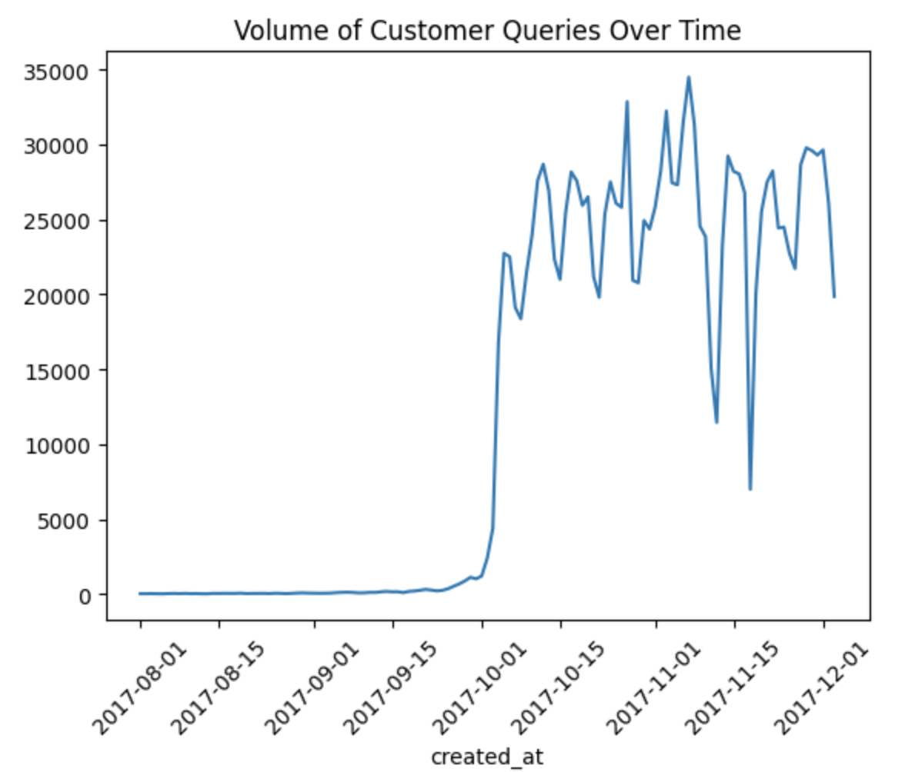

**Visualization 2: Average Response Time of Top 10 Support Accounts**

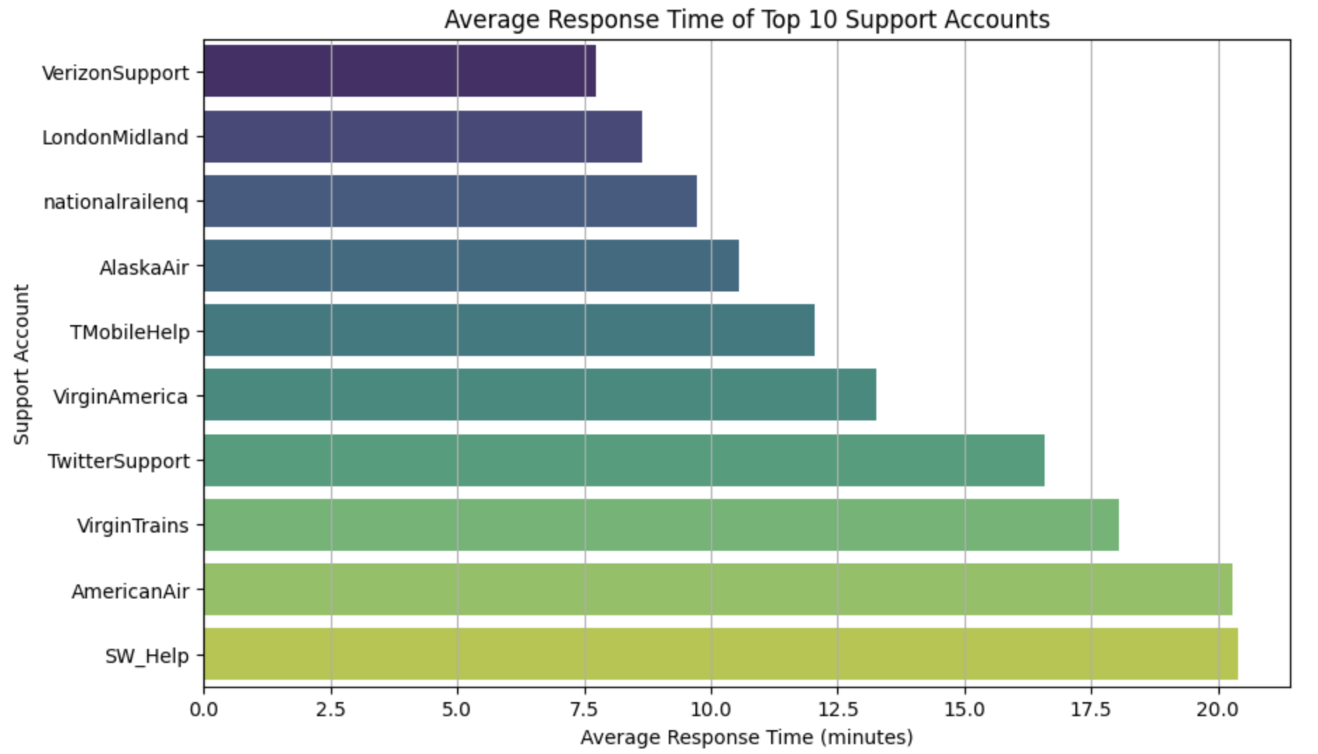

**Visualization 3: Word Cloud for Top Words in Frequent User Queries**

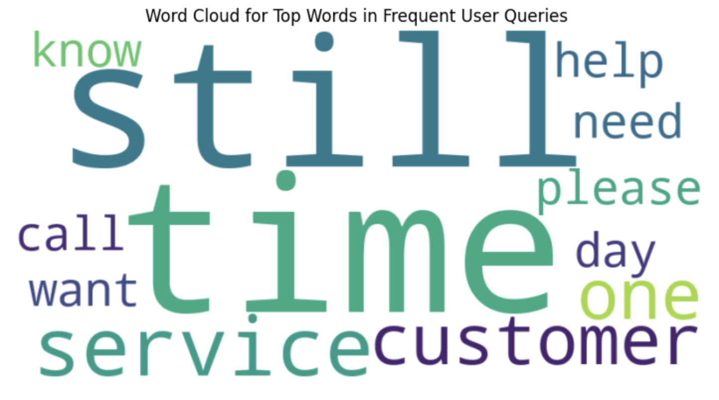

**Visualization 4: Word Cloud for Top Bigrams in Frequent User Queries**

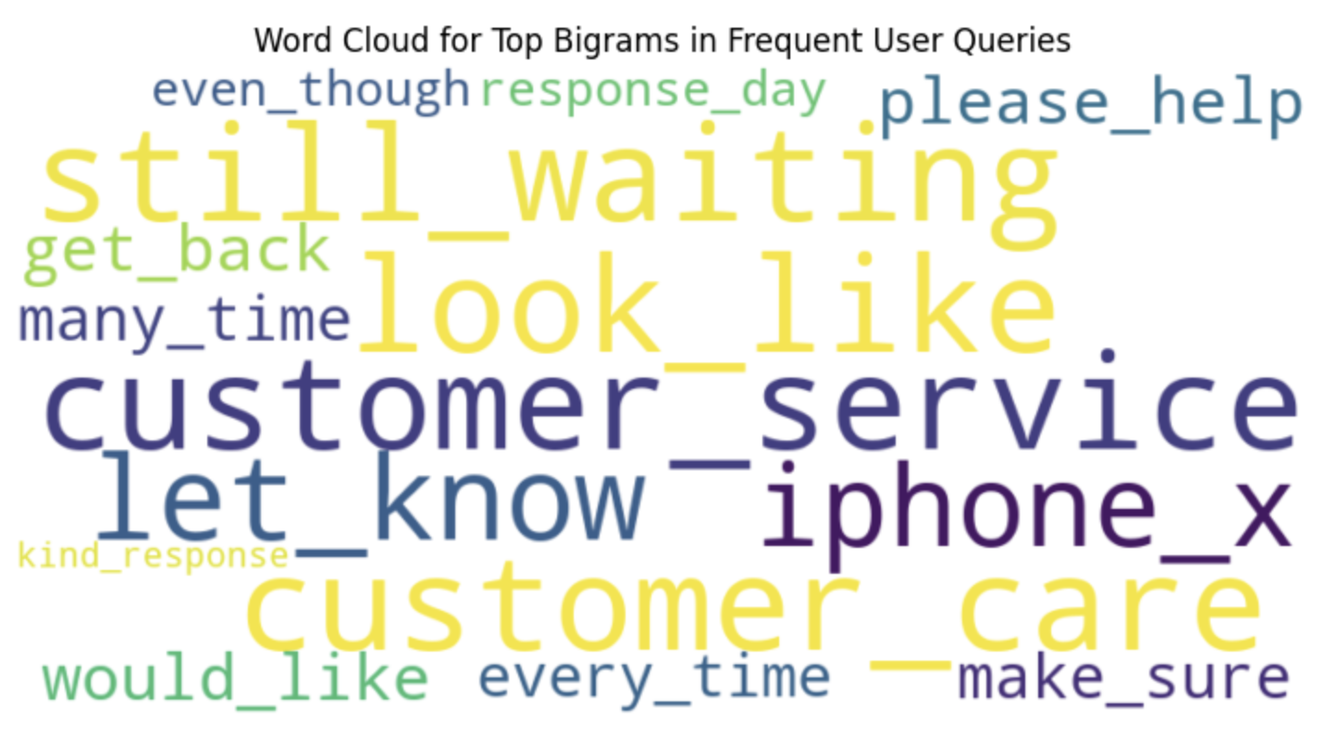

**Visualization 5: Average Response Time Comparison**

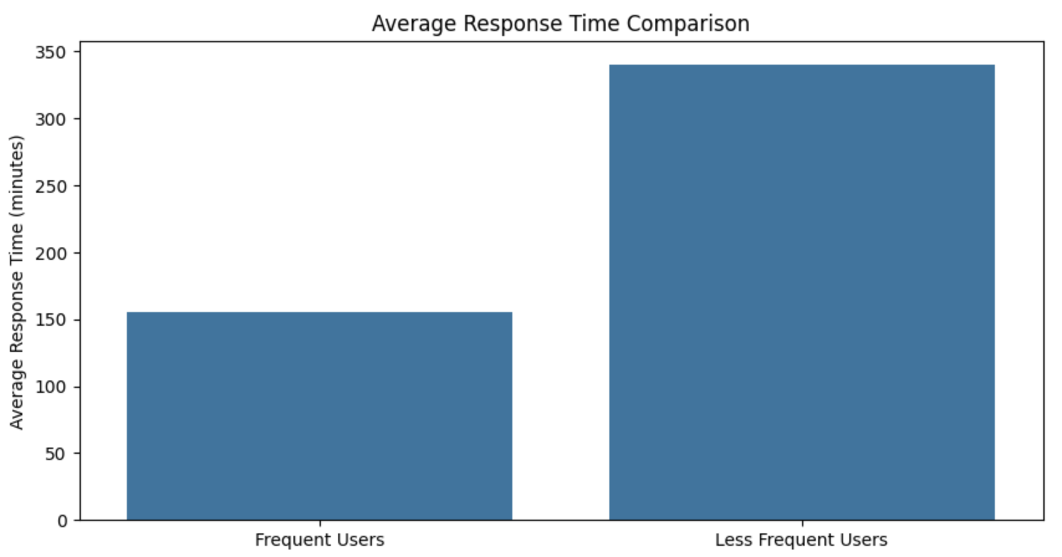

**Visualization 6: Average Response Length Comparison**

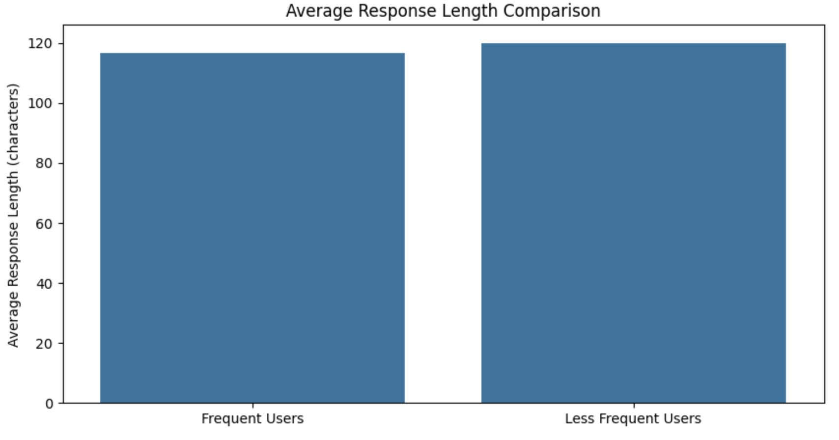

**Visualization 7: Word Cloud for Dissatisfaction or Urgency**

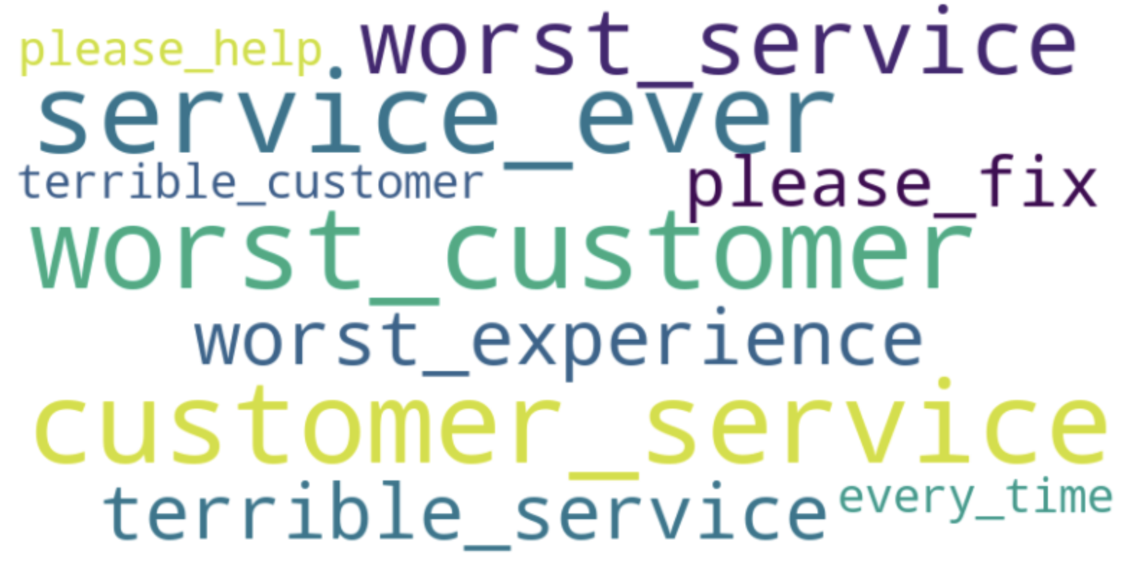

**Visualization 8: Word Cloud for Effective Support Responses**

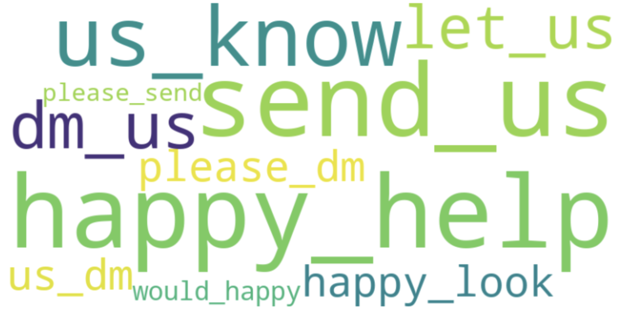

**Visualization 9: Distribution of Sentiment Change**

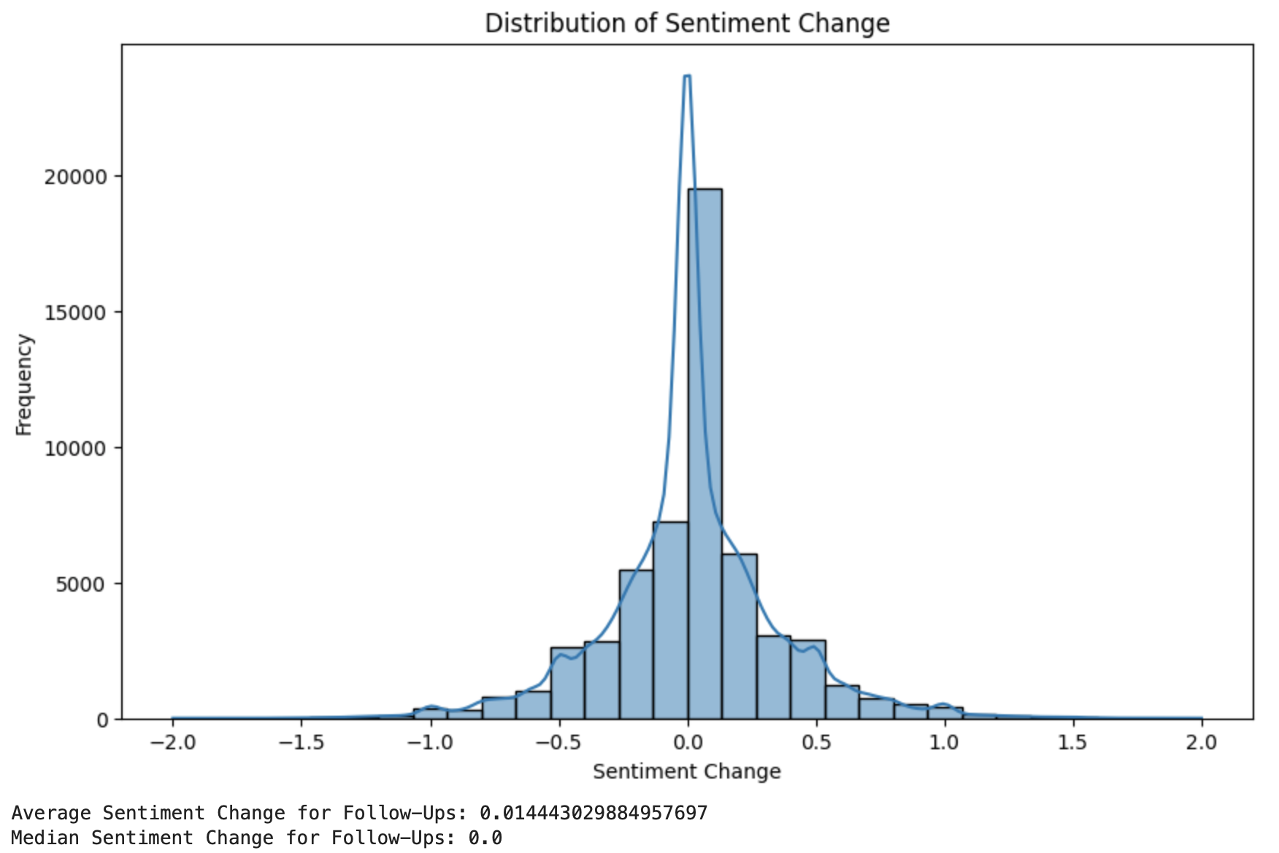

**Visualization 10: LDA**

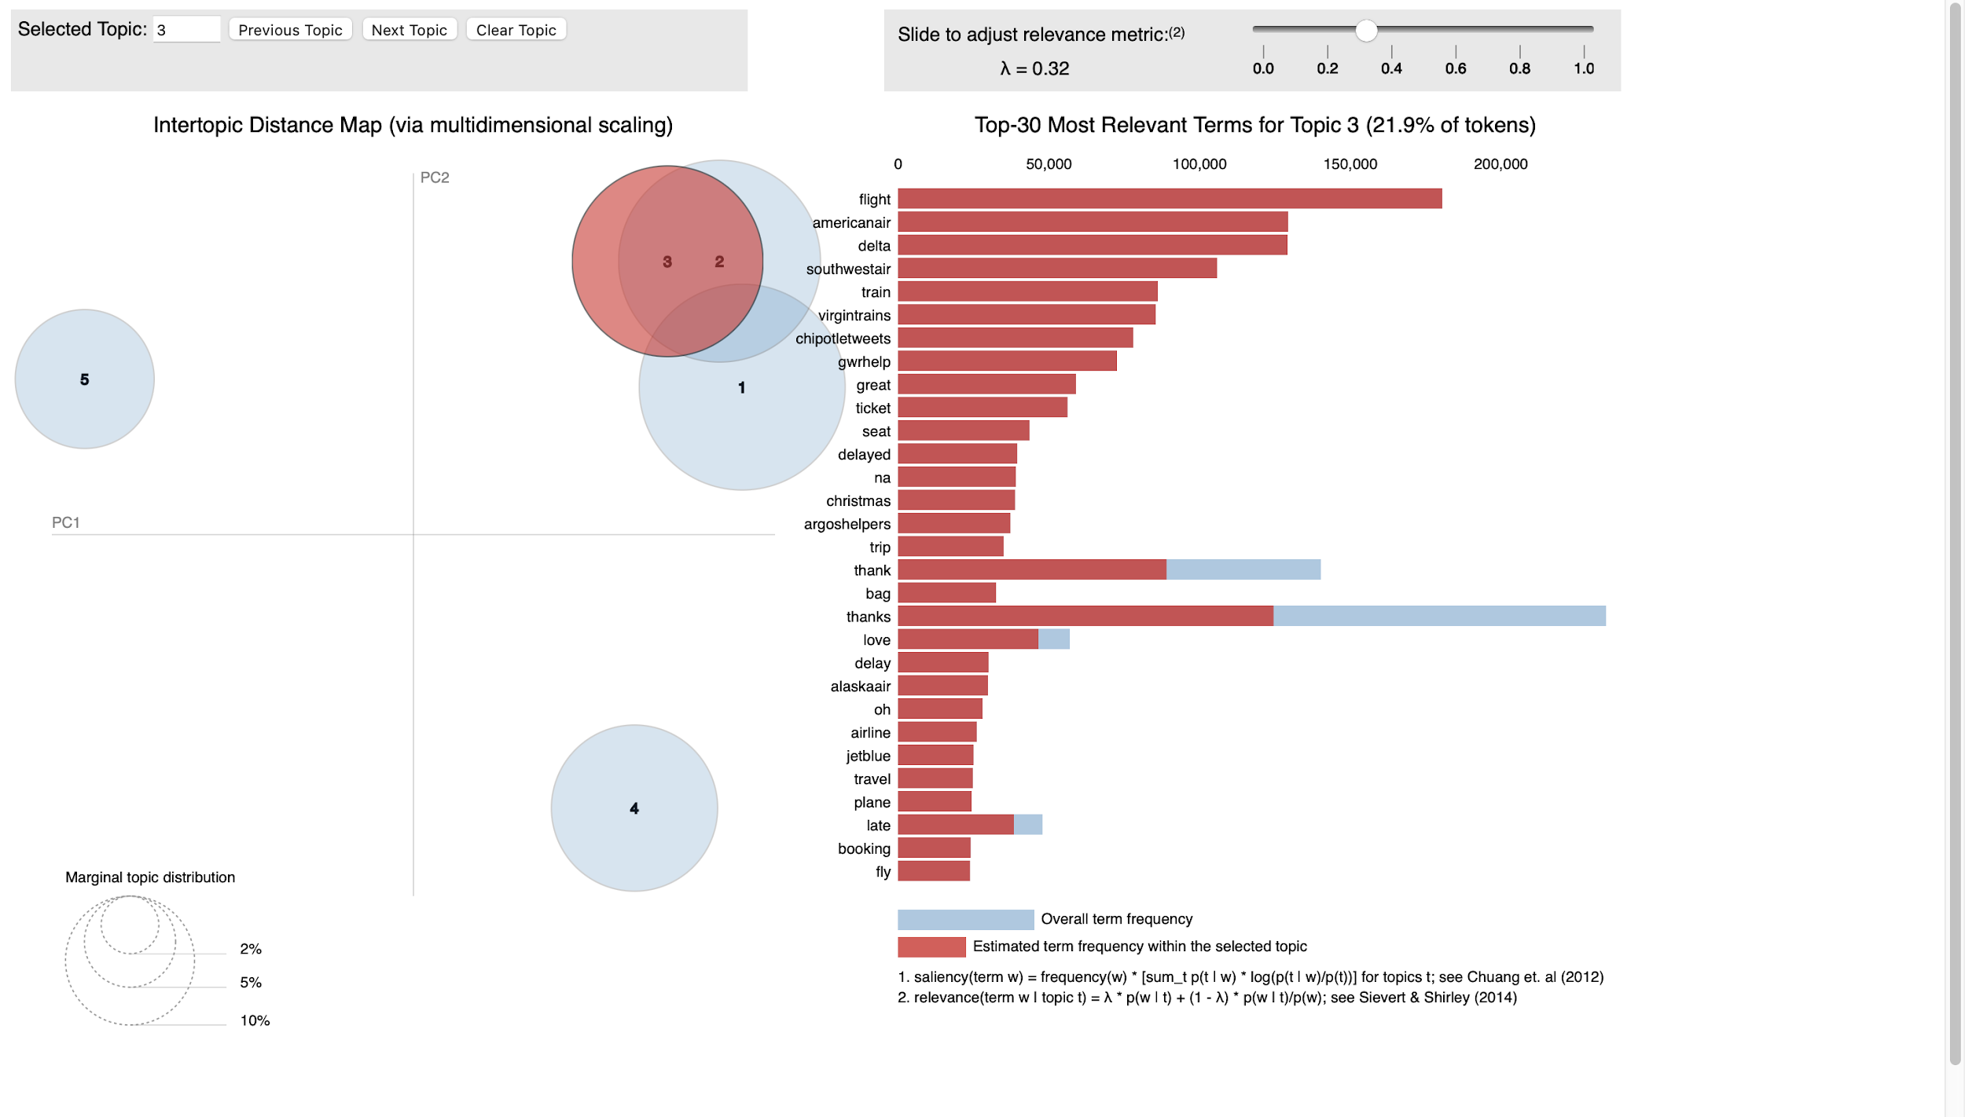

**Social Computing Concepts in Customer Support on Twitter:**

* **Distributed Cognition:**
  + LDA findings illustrate distributed cognition, showing how Twitter acts as a cognitive network, with knowledge spread across users, support agents, and online resources.
  + The sharing of URLs extends cognitive resources, linking customers with external knowledge bases and FAQs.
* **Media Multiplexity Theory:**
  + Analysis of Twitter's role in customer support echoes media multiplexity theory, where multiple communication channels strengthen brand-consumer relationships.
  + Twitter's integration into the broader customer support system highlights its function as a complementary channel.
* **Social Proof:**
  + Engagement patterns on Twitter demonstrate social proof, with users potentially influenced by visible brand interactions and resolutions.
  + The trend of positive sentiment shifts post-interaction may reflect social proof's impact on users' perceptions of brand service quality.
* **Use of LDA:**
  + LDA, a method learned in class, was key in analyzing Twitter data to identify common themes in customer support, showcasing the practical application of class-taught methods in analyzing social computing dynamics.

**Limitations:**

* Data Scope and Sampling: Although the dataset is comprehensive, it may not encompass the full spectrum of customer support interactions on Twitter. There's a potential bias, as the data might lean more towards interactions with high-profile brands or be concentrated within specific periods, leaving out smaller brands or other crucial timeframes.
* Operational Metrics: The study relies on certain metrics such as response time and the frequency of follow-ups to gauge the effectiveness of support. However, these metrics, while informative, might not wholly represent a user's overall satisfaction or the true quality of the resolution provided. There's more to user satisfaction than just quick responses.
* Accuracy of Sentiment Analysis: The research employs automated tools like TextBlob for sentiment analysis. While these tools are powerful, they have inherent limitations. They might not always discern the true sentiment behind tweets, especially those with subtle nuances, sarcasm, or cultural context, leading to potential misinterpretations.
* Unaccounted External Influences: The dataset might not factor in external events or circumstances, such as product launches, public relations challenges, or global events, which can significantly impact the volume, nature, and sentiment of tweets. Without this context, some spikes or trends in the data might remain unexplained.
* Dynamic Nature of social media: Twitter's algorithm and user behavior are constantly evolving, which means findings may not be applicable in the long term or might require continuous analysis for updated insights.
* Contextual Understanding: Automated analysis might miss the contextual cues that humans would naturally pick up on, such as irony or references to current events, which could affect the interpretation of tweets.

**Conclusion:**

In conclusion, our research has illuminated the dynamics of Twitter as a platform for customer support, revealing the intricacies of customer support interactions. Through sentiment analysis, we discovered nuanced patterns of customer satisfaction and dissatisfaction. The LDA method, a focal point from the course, effectively identified prevalent themes and topics within customer discourse. Response time analysis underscored the necessity for timely brand engagement, and the examination of user engagement patterns provided insights into the behaviors of different user groups. Despite the limitations regarding data scope and analysis tools, the study offers a significant contribution to understanding social computing within customer support and lays a foundation for future research to build upon, particularly in optimizing digital customer service strategies.